Practical no:6

import javax . swing.*;
import java.awt.*;
import java.awt.event.*;
public class jcombo_demo
{
jcombo_demo() {
JFrame F = new JFrame();
String cities[] = {"Mumbai", "Solapur", "Pune", "Bangalore"};
JComboBox cb = new JComboBox(cities);
cb.setBounds(10, 10, 150, 50);
F.add(cb);
F.setLayout(null);
F.setSize(400, 400);
F.setDefaultCloseOperation(JFrame.EXIT_ON_CLOSE);
F.setLocationRelativeTo(null);
F.setResizable(false);
F.setVisible(true);
}

public static void main(String[] args) {
new jcombo_demo ();
new jcombo_demo();

}
}

OUTPUT:-

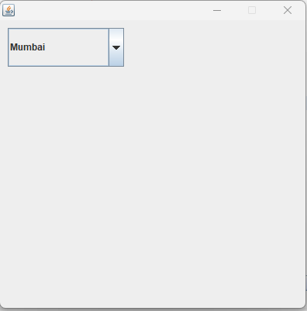

Q2.
import javax . swing.*;
import java.awt.*;
import java.awt.event.*;
public class combobox1 {

combobox1() {
JFrame F = new JFrame();
String State[] = {"India", "Kerala", "Goa", "Gujrat"};
JComboBox cb = new JComboBox(State);
cb.setBounds(10, 10, 150, 50);
F.add(cb);
F.setLayout(null);
F.setSize(400, 400);
F.setDefaultCloseOperation(JFrame.EXIT_ON_CLOSE);
F.setLocationRelativeTo(null);
F.setResizable(false);
F.setVisible(true);
}

public static void main(String[] args) {
new combobox1 ();
new combobox1();

}
}

OUTPUT:-
